What’s Next Project by Navigo Nepal

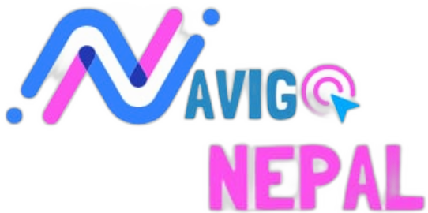

Team members (who participated):
Anupam Nyaupane
Biyog Man Dangol
Prajwal Dhungana
Swapnil Sapkota
Atal Raj Poudel

Date: 28th April, 2024

About Navigo Nepal
What’s next? This is a question we all ask ourselves on different stages of life. It’s a question that haunts us when we are about to embark into another chapter of our life. And talking about important chapters of life, what could be more important than education? Education is one of the most important yet most unmanaged and compromised aspects of Nepal. We all were oblivious on what to do after completing grade 10. We all felt that its end to the never ending tortures of homework and nightmares of exams. Little did we know, those things were about to be even more serious instead. We, personally, felt very difficult to cope up with the academic pressure in 11th and 12th grade, so much that most of our time was being invested in just passive studying and not really learning. We didn’t get many opportunities to follow our inner passion and- be ourselves. It was not the problem of only us but most of the students of Nepal. This is when we felt that there is huge gap in the educational system when students go through this transition stage. So, with the objective to overcome this gap and provide students with academic as well as extracurricular prowess, while not overwhelming them with the vast opportunities and competition going on, Navigo Nepal was born.
Navigo Nepal is a non-profit organization which helps students in navigating their path after 10th grade while also providing valuable knowledge on personality development to be an aware, responsible and intellectual part of their community. Our aim is basically providing those things to students of this generation that the previous generation needed but didn’t get.

About the project
This report is about the What’s Next project that we did in two schools of Nuwakot and Dhading district. Both projects had similar structure and similar outcomes. We first contacted the principals of respective schools for permission to conduct our program there and to discuss the timing also. The schools where we conducted our project were also similar in terms of infrastructure, reach, and number of students. Navigo Nepal, being located in Kathmandu, travelled to these two schools to conduct our programs.
What’s Next – Chandrajyoti School, Pipaltar, Nuwakot
Chandrajyoti is a small government school located in Nuwakot district. We choose to do our first program in this school to know what the quality of academics is and extracurricular resources are like in rural areas. We prepared various presentation slides including fun games to make our session interactive. Our session was directed towards the students of grade 9 and 10. In total, a number of 100 students received our session.
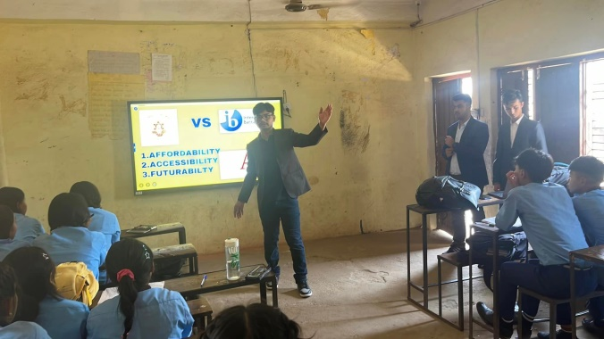
The presentation slides consisted of crucial information to help students understand the various options available to them after 10th grade, including different streams, courses, and colleges. Occasionally, we asked students perplexing questions and conducted activities not to make the session one sided. It included asking students on their goals, and what they have been doing, or what they could do, in and out of school to achieve those goals.
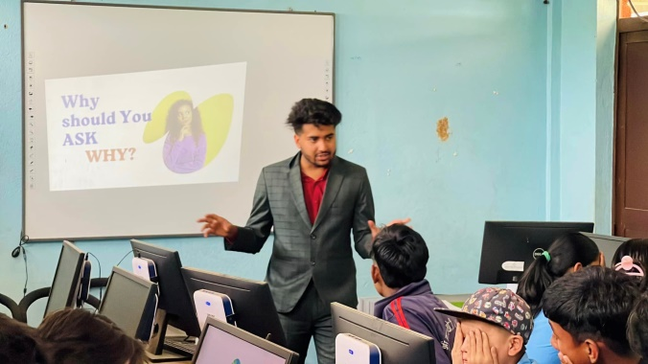
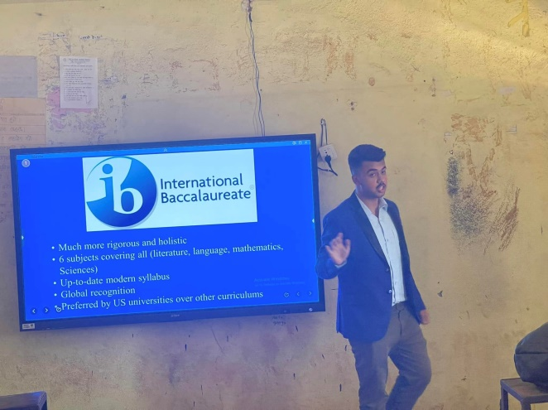
Fig: Members of Navigo Nepal giving presentation to students
We divided our whole session into two major parts. One was focused on mainly providing essential information on helping students navigate their paths after grade 10th and the other was focused on extracurricular activities such as student clubs which the students were completely unaware of. Mr. Prajwal Dhungana ,Mr. Biyog Man Dangol and Mr. Swapnil Sapkota took the lead for the former while Mr. Anupam Nyaupane and Mr. Atal Raj Poudel for the latter. We were provided with projector as well as a digital board to conduct our session.
Our whole session can be condensed into these three following points:
- Empower Students: We helped students understand the various options available to them after 10th grade, including different streams, courses, and colleges. Our goal was to equip them with the knowledge to make informed decisions about their future education.

- College and Course Selection: We presented detailed information on how students can choose the best college and course that aligns with their interests, strengths, and career aspirations. This included insights into admission processes, scholarship opportunities, and factors to consider when making their choices.

- Skill Development for Student Clubs: In addition to academic guidance, we provided students with the skills needed to establish and run successful student clubs within their school. This included leadership, organization, communication, and teamwork skills, which are essential for personal development and fostering a vibrant school community.

To sum up,
We all had an incredible experience with students of both schools while conducting our powerful sessions. While we had ventured to provide students the learning that they critically needed, we didn’t presume that we ourselves will learn new things we never thought of. We felt what it really feels like being a very important help to students who really needed it. It gave us the kick start we needed to expand our reach to other schools and institutions all over the country. The project was equally fruitful for both students as well as us. We also observed that when young individuals like ourselves engage in supporting students, both the principal and the entire school management show no disagreement and warmly welcome and appreciate our efforts. We continue to make the students learn and learn ourselves from experiences with them.

